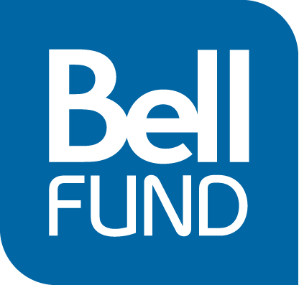

Final Report Guidelines - Development

The goal of the Final Report is to allow digital media producers to review and summarize the highlights and challenges of the completed project and outline the lessons learned. The Final Report also helps the Bell Fund evaluators in appraising the completed project and in applying your experience to future applications they evaluate. It may also provide helpful advice or problem-solving tips to be shared with others where appropriate. Use the following questions as guidelines to write a strong Final Report.

- Content

A. In 100 words or less (not more!), summarize your project.

B. Compare the content as outlined in the original proposal with the final deliverables and discuss the outcomes. Are there significant changes? Identify the reasons and impacts. Please make sure to include any url for the project so that the evaluators can view the results directly. Please attach all paper deliverables (ie production budget, production schedule, wireframes, flowcharts, business plan). Following is a chart which may serve as a model to organize your discussion about your content.

Summarize each of the deliverables in the Proposal | Describe the final deliverable | Comments and outcome  (compare and elaborate on challenges and successes of the various components)
1.

2.

3.

Etc.

- Budget/Financial

Describe any significant changes to the development budget and development financial structure and explain why these changes occurred. Include information on any significant variances and explain reasons.

- Business Plan and Marketing

Identify actual revenues and potential business opportunities you are pursuing. Summarize business and marketing planning activities. What research activities did you undertake? How did the results of your research affect your original plan?

4. Broadcaster Relationship

Describe your working relationship with the broadcaster during development.

5. Collaborators

Every successful project involves communication between team members. We are interested in hearing how the various teams involved in your project (broadcaster, digital media producers, and/or television producers, independent consultants) worked together. Was the project supported on all fronts, or did each component work separately? Were schedules met? Was there a smooth work-flow?

6. Successful Elements

What is the most successful element of the development of this project for you? Also, include information on areas that were not successful. What aspects did not live up to your expectations? Include graphics, screenshots or examples to highlight your successes.

7. Going Forward

What are the plans for the production or further development of this project? Summarize production plans, schedule, financing, partners.

8. Lessons Learned

What lessons have you learned from this project? Discuss any challenges you faced including technical, creative, and/or financial issues. Share how you overcame these challenges and how you might try to prevent these obstacles in the future.

